TASK 5 — Header Files & Conditional Compilation

1. Header Structure Layout (billing.h)
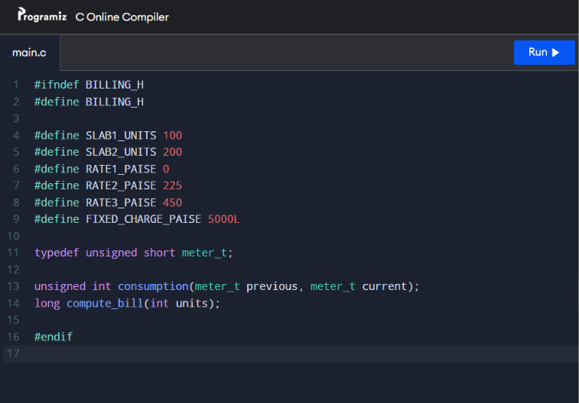

2. Main Logic with Debugging Toggles (main.c)
